Contents

Create an APIM instance 1

Check the Developer Portal 3

Publish the service 3

Add new API 3

New api is created 6

Test the new Api: 6

Create and publish a product 7

Transform your API by using policies 9

Define the policy 9

Test the modified response 10

# Create an APIM instance

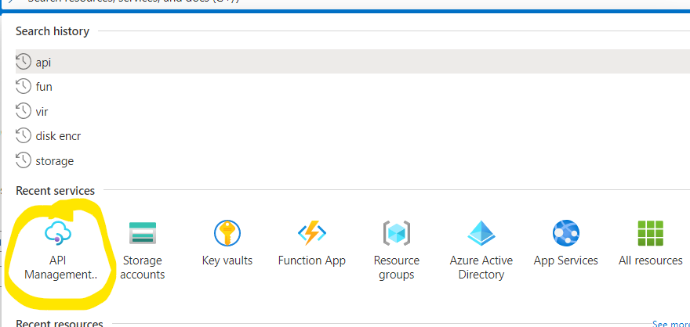

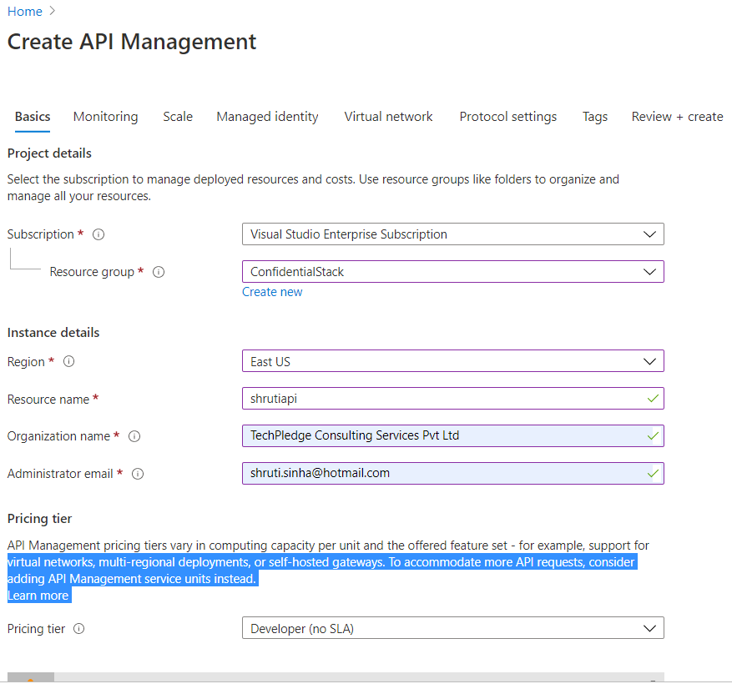

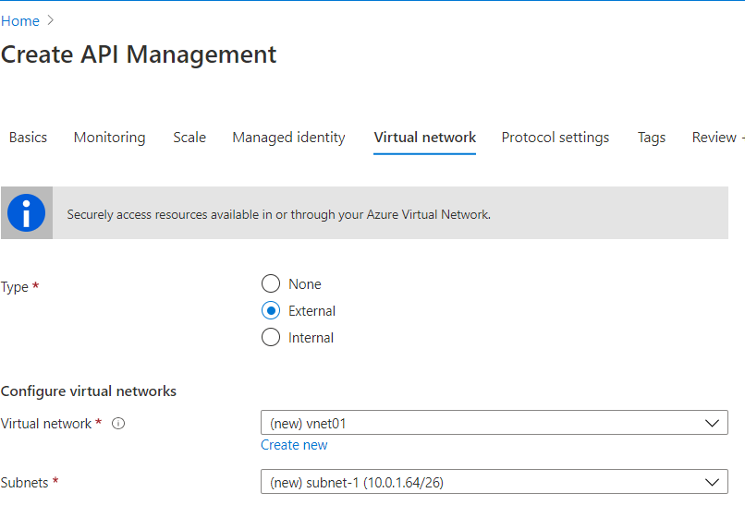

# Check the Developer Portal

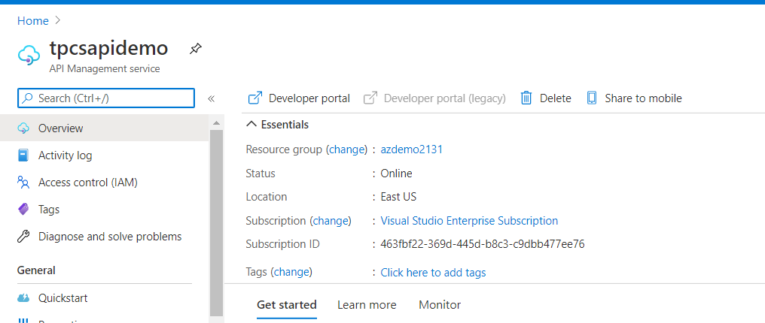

# Publish the service

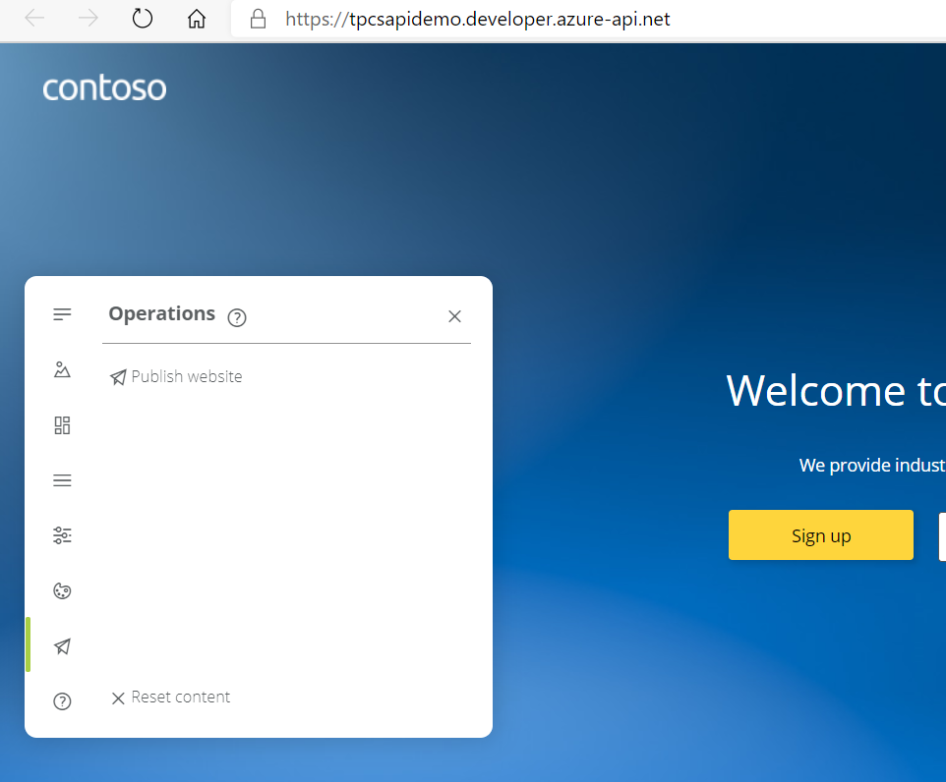

Copy the URL and open in private window to confirm the website is publishes

# Add new API

Go to Azure portal>> APISM

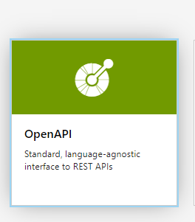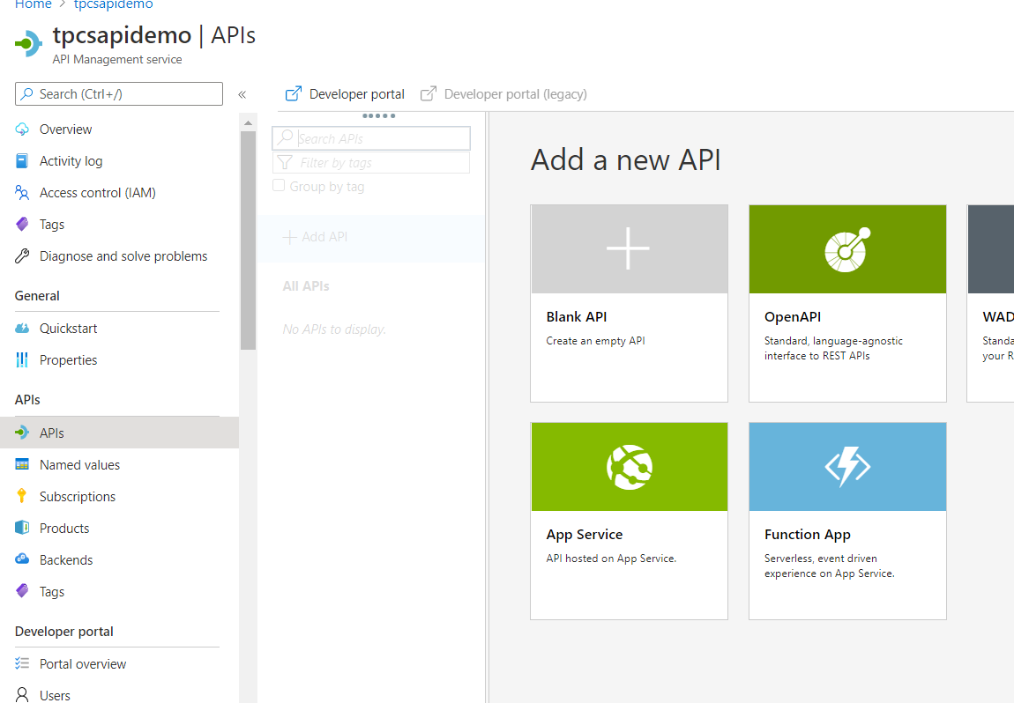

Launch OpenAPI in full mode:

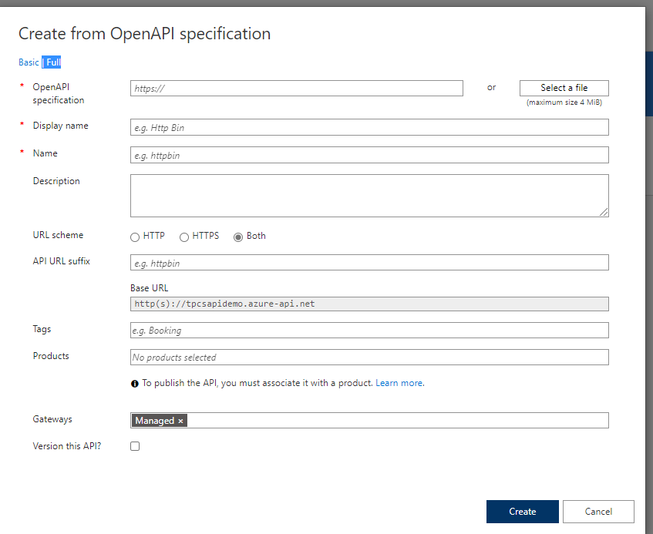

|  |  |  |
| --- | --- | --- |
| Setting | Value | Description |
| OpenAPI Specification | <https://conferenceapi.azurewebsites.net?format=json> | References the service implementing the API. API management forwards requests to thisaddress. |
| Display name | Demo Conference API | If you press tab after entering the service URL, APIM will fill out this field based on what is in the json. This name is displayed in the Developer portal. |
| Name | demo-conference-api | Provides a unique name for the API. If you press tab after entering the service URL, APIM will fill out this field based on what is in the json. |
| Description | Provide an optional description of the API. | If you press tab after entering the service URL, APIM will fill out this field based on what is in the json. |
| URL scheme | HTTPS | Determines which protocols can be used to access the API. |
| API URL | conference | The suffix is appended to the base URL for the API management service. API Management distinguishes APIs by their suffix and therefore the suffix must be unique for every API for a given publisher. |
| Tags | blank | Tags for organizing APIs. Tags can be used for searching, grouping, or filtering. |
| Products | blank | Products are associations of one or more APIs. You can include a number of APIs into a Product and offer them to developers through the developer portal. |
| Version this API? | Leave unchecked | For more information about versioning, see Publish multiple versions of your API (https:// docs.microsoft.com/en-us/azure/ api-management/api-management-get-started-publish-versions) |
|  |  |  |

## New api is created

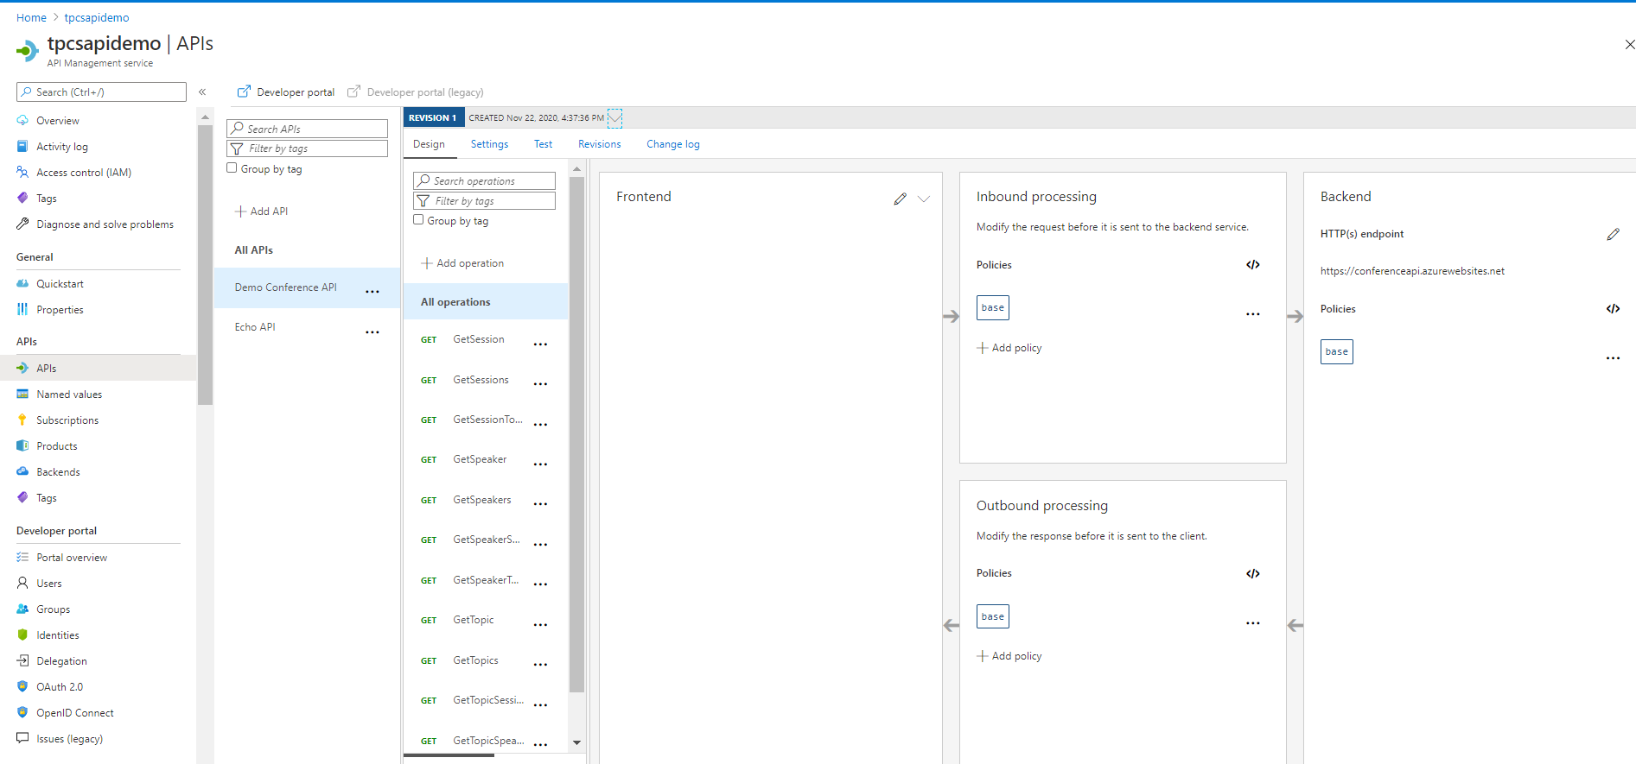

## Test the new Api:

Operations can be called directly from the Azure portal, which provides a convenient way to view and test

the operations of an API.

* Select the API you created in the previous step (from the APIs tab).
* Press the Test tab.
* Click on GetSpeakers. The page displays fields for query parameters, in this case none, and headers.

One of the headers is Ocp-Apim-Subscription-Key, for the subscription key of the product that

is associated with this API. The key is filled in automatically.

* 4. Press Send.

Backend responds with 200 OK and some data.

✔️ Note: We will continue to leverage this API in demos throughout the remainder of this module.

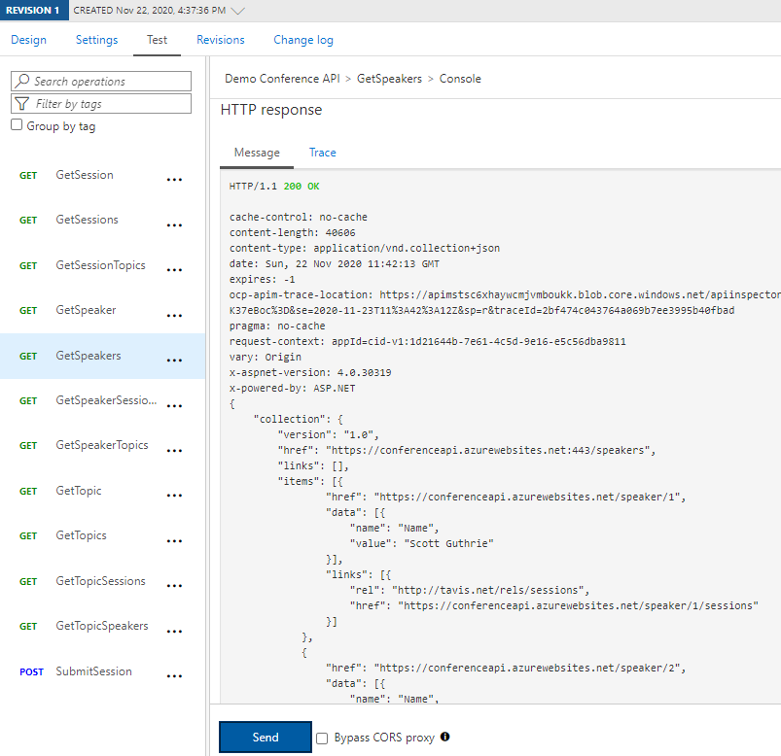

# Create and publish a product

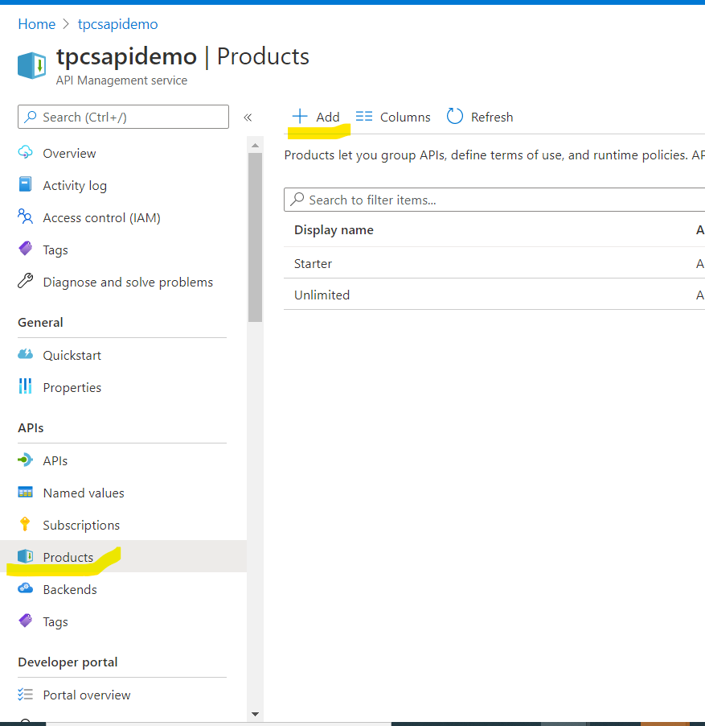

|  |  |  |
| --- | --- | --- |
| Setting | Value | Description |
| Display name | AZ204 API Demo | The name as you want it to be |
| shown in the Developer portal. |
| Id  . | az204-api-demo | This is auto-populated when you |
| tab out of the Display name |
| field |
| Description | AZ204 Class Demo | The Description field allows you |
| to provide detailed information |
| about the product such as its |
| purpose, the APIs it provides |
| access to, and other useful |
| information. |
| State | Select Published | Before the APIs in a product can be called, the product must be published. By default new products are unpublished, and are visible only to the Administrators group. |

Requires subscription Leave unchecked Check Require subscription if a user is required to subscribe to use the product.

|  |  |  |
| --- | --- | --- |
| Requires approval | Leave unchecked | Check Require approval if you want an dministrator to review and accept or reject subscription attempts to this product. If the box is unchecked, subscription attempts are auto-approved. |
| Subscription count limit | Leave blank | To limit the count of multiple simultaneous subscriptions, enter the subscription limit. |
| Legal terms | Leave blank | You can include the terms of use for the product which subscribers must accept in order to use the product. |
| APIs | Select Select API and add the Demo Conference API | Products are associations of one or more APIs. You can include a number of APIs and offer them to developers through the developer portal. |
|  |  |  |

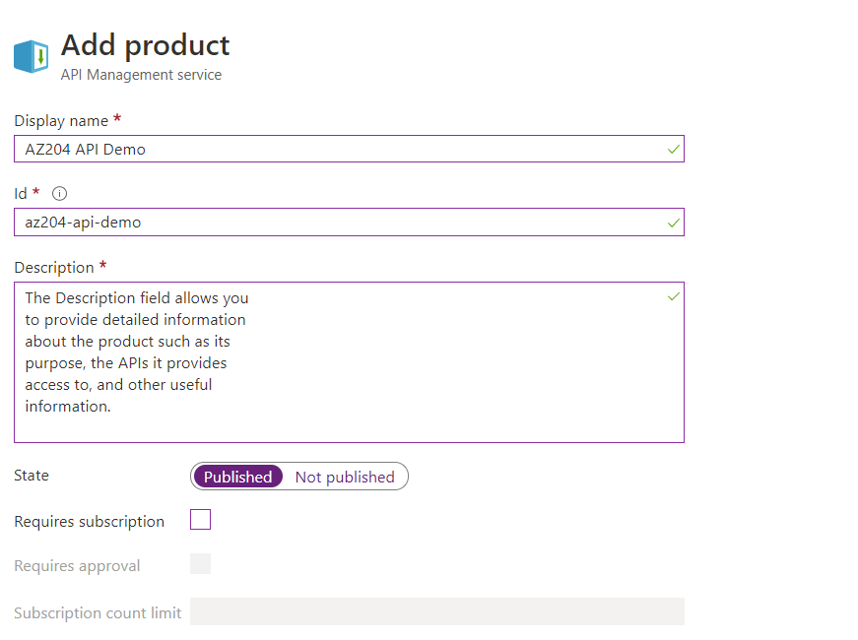

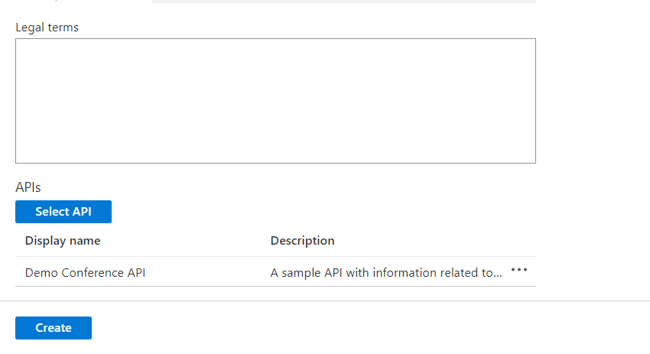

# Transform your API by using policies

Test the original response

1. Select the Test tab, on the top of the screen.

2. Select the GetSpeakers operation.

3. Press the Send button, at the bottom of the screen. The response includes the response headers

below:

x-aspnet-version: 4.0.30319

x-powered-by: ASP.NET

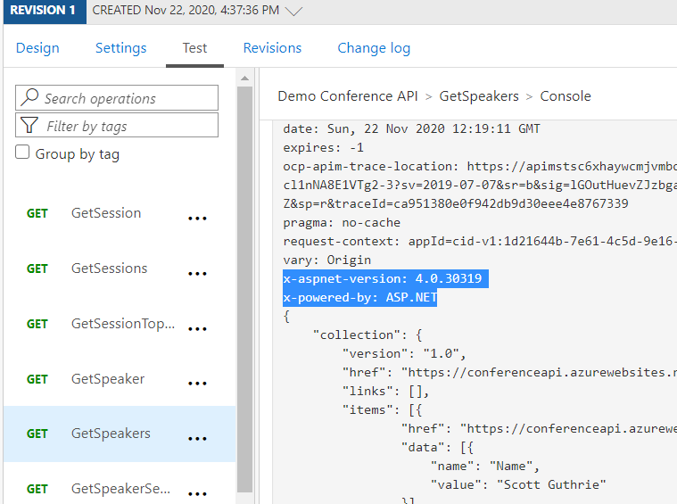

## Define the policy

1. On the top of the screen, select Design tab.

2. Select All operations.

3. In the Outbound processing section, click the </> icon.

4. Modify your <outbound> code to look like this:

<outbound>

<set-header name="X-Powered-By" exists-action="delete" />

<set-header name="X-AspNet-Version" exists-action="delete" />

<base />

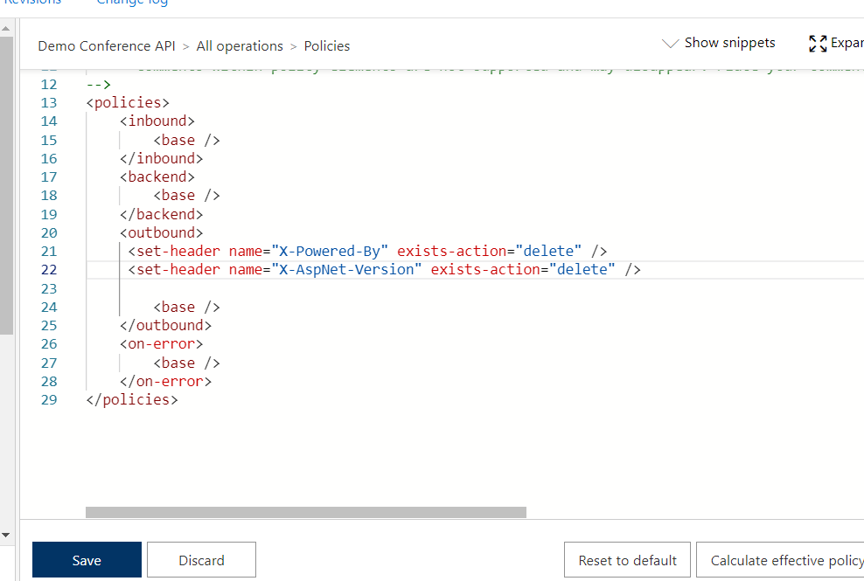</outbound>

5. Select Save.

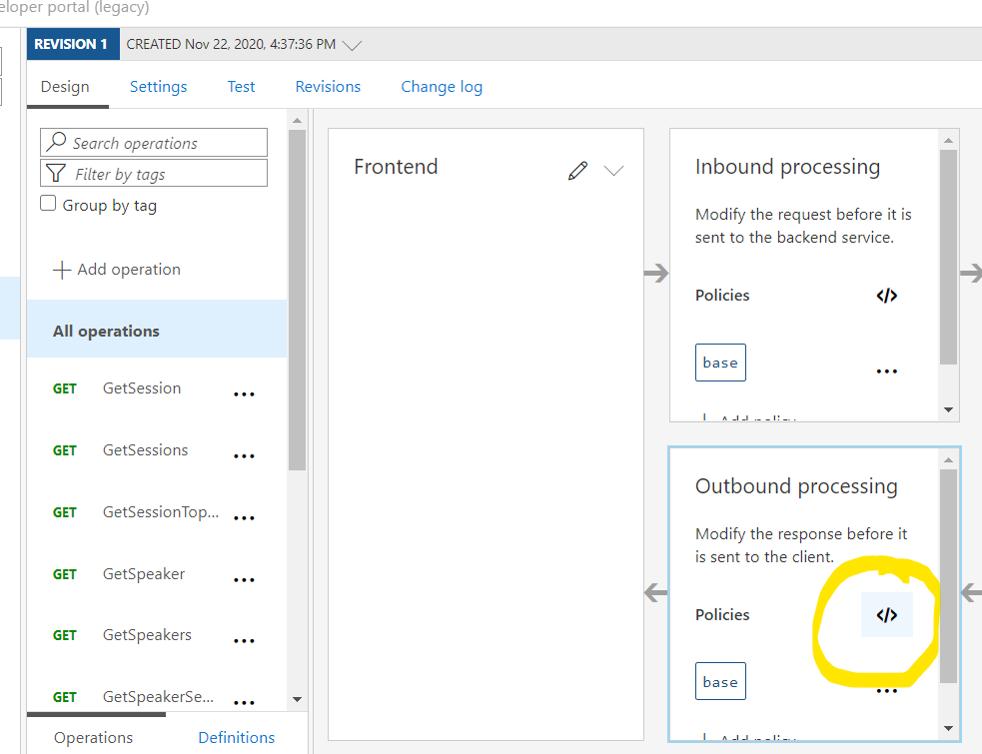

6. Inspect the Outbound process section and note there are two set-header policies listed.

## Test the modified response

1. Select the Test tab, on the top of the screen.

2. Select the GetSpeakers operation.

3. Press the Send button, at the bottom of the screen.

The response no longer includes platform information related to your API.

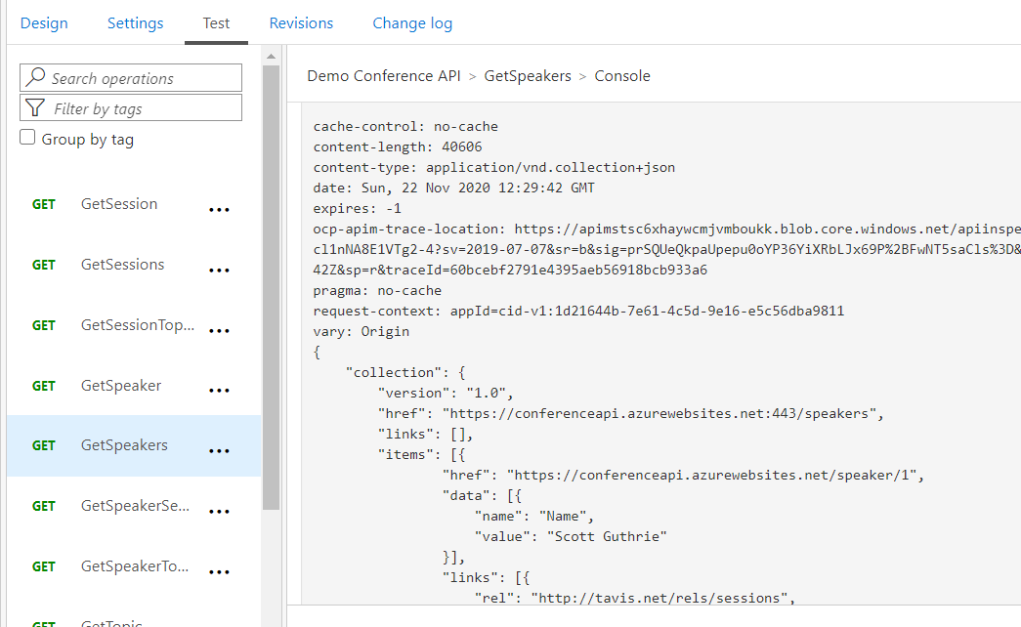

**The response no longer includes platform information related to your API.**